Task4a:

NTEM Sales Services has provided the new system requirements. These are:  
• the existing code provided allows users to select a salesperson and show the value of  
sales made over a period of time  
• the solution must also identify trends and patterns over a period of time for:  
– the value of sales for different regions  
– the employees with the highest sales values  
• the solution must be secure.  
NTEM Sales services has also provided user requirements for the solution. These must:  
• be easy to use  
• display information in a meaningful way  
• make use of appropriate textual, numerical and graphical output in a way that would  
be relevant to the end user.

**Evaluation:**

I have chosen pandas as one library to use as it’s specialized in manipulating data.

I also chose to use the matplotlib library as it specializes in generating graphs and it goes well with pandas.

I have made the code more secure as I have changed a few of the variable names to something easier to understand what it does and where it’s being used.

I also made use of proper graphical, numerical and textual output by allowing the user to choose the dates for the graphs that represent the sales made over time.

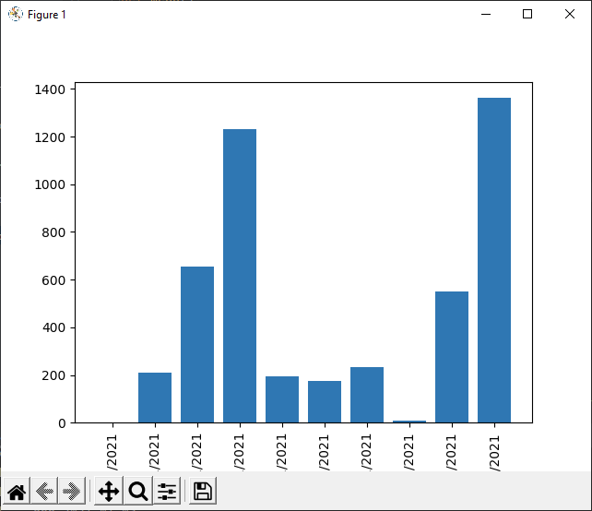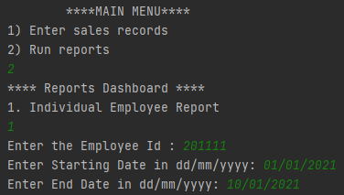

However, it fails to meet the requirements, once you select one option, you can’t choose the other unless the code is being ran again. It only consists of its original functions and no additional features have been added.

One thing I would change is the way the two options are run by making the two options in two different functions and calling them respectively at the end. This would allow for proper running of the menu and can choose between option 1 and option 2 every time on the menu. This would allow for better security as it would be arranged more appropriately and effectively.